WEEK 2 ASSESSMENT EXERCISE

Your repository: ________________________________

OVERVIEW

Use CSS and JavaScript to complete this app. We’ve given you a mostly-working application with just a bit of JavaScript missing and a lot of CSS missing. Bootstrap is also installed. Using Bootstrap is totally optional. When finished, simply commit and push your work.

Below is a visual guide for how the application should look and function.

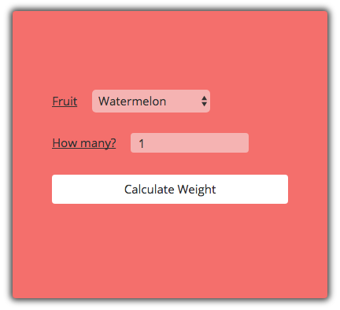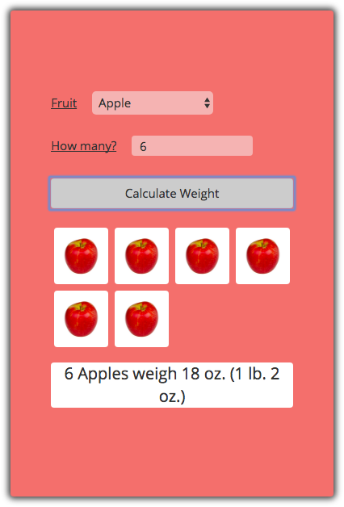

The page starts out looking like the image on the **left**.

After you pick a fruit and a number and click “Calculate Weight”, it shows a total weight and images of the number of fruit selected. (Image on **right**.)

continued on back...

REQUIREMENTS

Detailed requirements are below. You can get partial credit depending on which of these you finish. Your final product does NOT need to look *exactly* like the images on the reverse as long as it meets the stated visual requirements below.

**WARNING:** Pay attention to how the point values are laid out below. You may not have time to finish everything. Prioritize your time to maximize your score.

FUNCTIONAL *[50 pts]*

Modify add-code-here.js. Complete the code by filling in the body of the two functions calcWeightInOunces and addFruitImages. We've already written the rest of the code.

* The calcWeightInOunces function...
  + calculates the correct weight. *[12.5 pts]*
  + returns that weight number. *[12.5 pts]*
  + (When this is correct, the total weight will be displayed.)
* The addFruitImages function...
  + calls addOneFruitImage, passing the fruit type. *[12.5 pts]*
  + calls addOneFruitImage the correct number of times. *[12.5 pts]*
  + (When this is correct, the appropriate number of images of fruit will be displayed.)

VISUAL *[50 pts]*

**TIP:** Add ?test-css to the end of your URL to display some fake results and images. This will make working on your CSS much easier.

Modify add-code-here.css in order to adjust the look of the page as follows. The page must be laid out roughly as pictured, including:

* The content div is this salmon color #F46F6C, and the results div is white. *[5 pts]*
* The content div is max 400 pixels wide and centered, with 40 pixels padding. *[5 pts]*
* The content div has a gray shadow. *[5 pts]*
* All buttons, inputs, images and divs have rounded corners of 4 pixels. *[5 pts]*
* The “Calculate Weight” button is white with black text and no border. It stretches the whole width of its container. *[5 pts]*
* The “Calculate Weight” button turns gray (#ccc) when hovered over. *[5 pts]*
* Labels are underlined. *[5 pts]*
* There is space (about 15 pixels) between the labels and their inputs. *[5 pts]*
* Images display four per row. *[5 pts]*
* Import and use the “Open Sans” for on the entire page. *[5 pts]*
* Bonus: Use HTML5 in index.html to prevent entering numbers of fruit less than 0. *[+5 bonus pts]*